**5. Modelling more complex transitions**

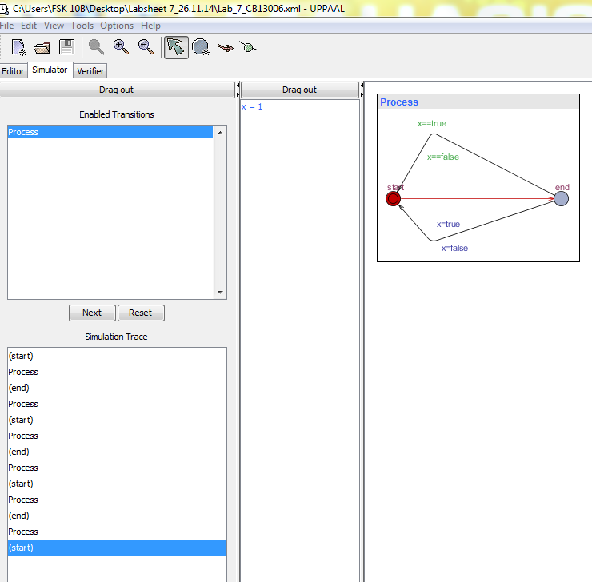

Comment :

1. The variables is declared as : bool x;
2. To simulate the system by enabled Transitions,the process view to the right will change and simulation trace will grow
3. The process run as x==true so that the value through that path is x=1.

**5. Develop the model of Inteligent Light Control System**

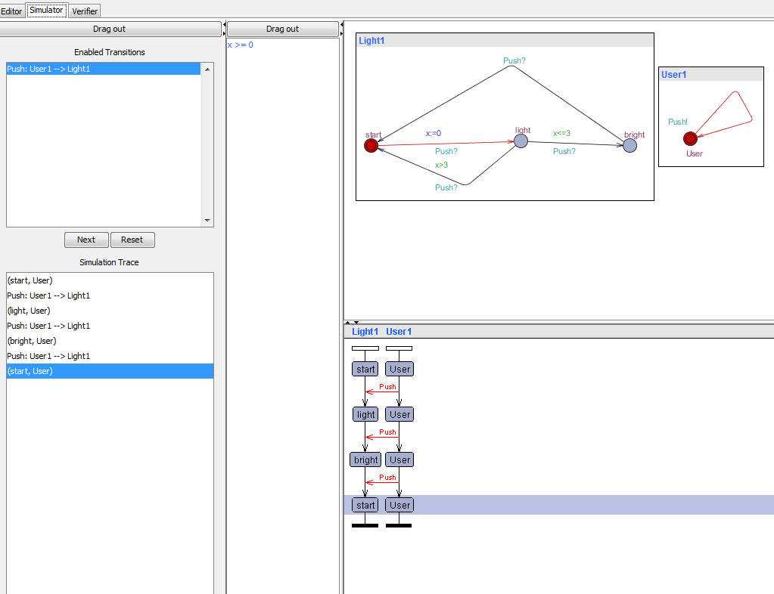

Comment :

1. The Global variables is declared as : clock x;

chan Puch;

1. Light and User are templates automations THEN Light1 and User1 are instances processes.

Declared System composed of Light1 and User1 processes.

1. To simulate the system by enabled Transitions,the process view to the right will change and simulation trace will grow

**5. . Check the property of the Light Control System :A[](x>=0)**

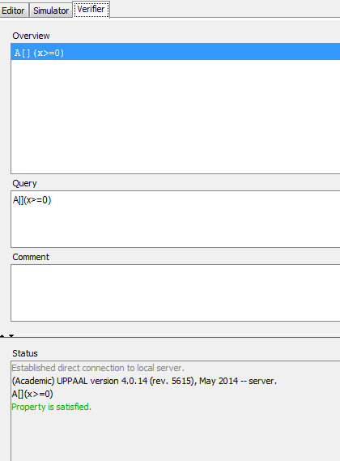

Comment :

1. The property to be checked: A[](x>=0) to reach the location Light and User in the system Light1 and User1.
2. Then Check will turn out greenindicating the property indeed is satisfied let engine to verify the function.